TASK 1: DNA/Protein Sequence Analysis
BLAST Homology Analysis of RecA Protein from Deinococcus radiodurans

1. Introduction
The objective of this task was to retrieve a protein sequence from a public sequence database (NCBI), perform a homology search using BLAST (Basic Local Alignment Search Tool), and document and interpret the resulting alignment statistics. The protein selected for this analysis is RecA, a DNA-repair and homologous-recombination protein, from the extremophilic bacterium Deinococcus radiodurans — an organism renowned for its exceptional resistance to ionizing radiation and DNA damage, largely attributed to highly efficient RecA-mediated repair pathways.

2. Sequence Retrieval
The protein sequence was retrieved from the NCBI Protein database using the following record:
- Protein: RecA [Deinococcus radiodurans]
- GenBank Accession: BAA21330.1
- Sequence length: 363 amino acids
- Source URL: ncbi.nlm.nih.gov/protein/BAA21330.1
The sequence was downloaded in FASTA format, shown below:
>BAA21330.1 RecA [Deinococcus radiodurans]
MSKDATKEISAPTDAKERSKAIETAMSQIEKAFGKGSIMKLGAESKLDVQVVSTGSLSLDLALGVGGIPR
GRITEIYGPESGGKTTLALAIVAQAQKAGGTCAFIDAEHALDPVYARALGVNTDELLVSQPDNGEQALEI
MELLVRSGAIDVVVVDSVAALTPRAEIEGDMGDSLPGLQARLMSQALRKLTAILSKTGTAAIFINQVREK
IGVMYGNPETTTGGRALKFYASVRLDVRKIGQPTKVGNDAVANTVKIKTVKNKVAAPFKEVELALVYGKG
FDQLSDLVGLAADMDIIKKAGSFYSYGDERIGQGKEKTIAYIAERPEMEQEIRDRVMAAIRAGNAGEAPA
LAPAPAAPEAAEA
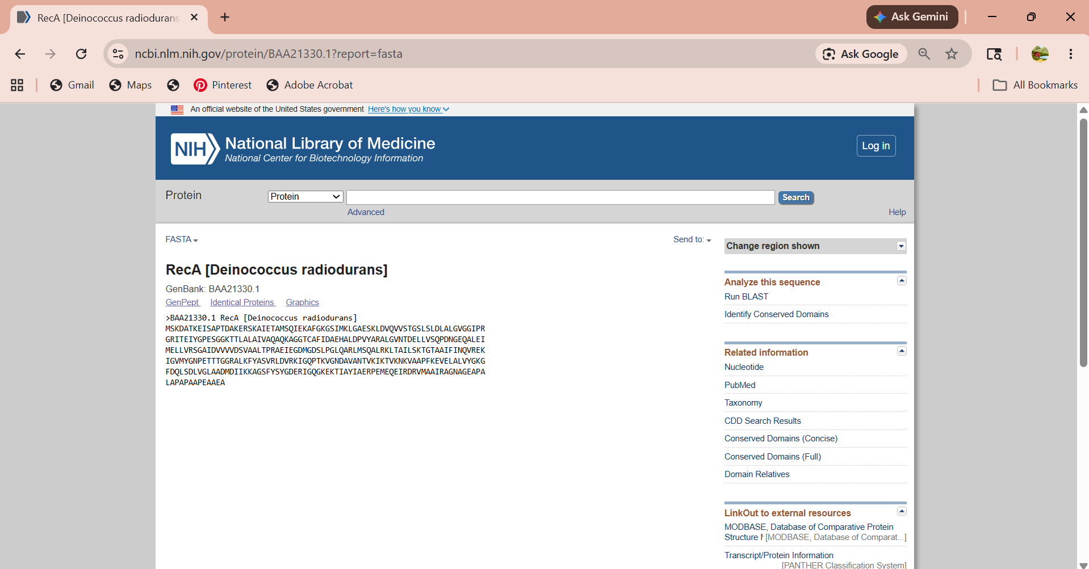

Figure 1. NCBI Protein record (FASTA view) for RecA, Deinococcus radiodurans (GenBank BAA21330.1).

3. BLAST Methodology
A protein-protein BLAST (BLASTP) search was performed against the Protein Data Bank (PDB) sequence database using the NCBI BLAST web suite, in order to identify structurally characterized homologs of the query RecA sequence. Default BLASTP scoring parameters were used (BLOSUM62 substitution matrix, compositional matrix adjustment enabled).
- Program: BLASTP
- Database: pdb (Protein Data Bank)
- Query length: 363 residues
- Request ID (RID): 3A9FVZXT016
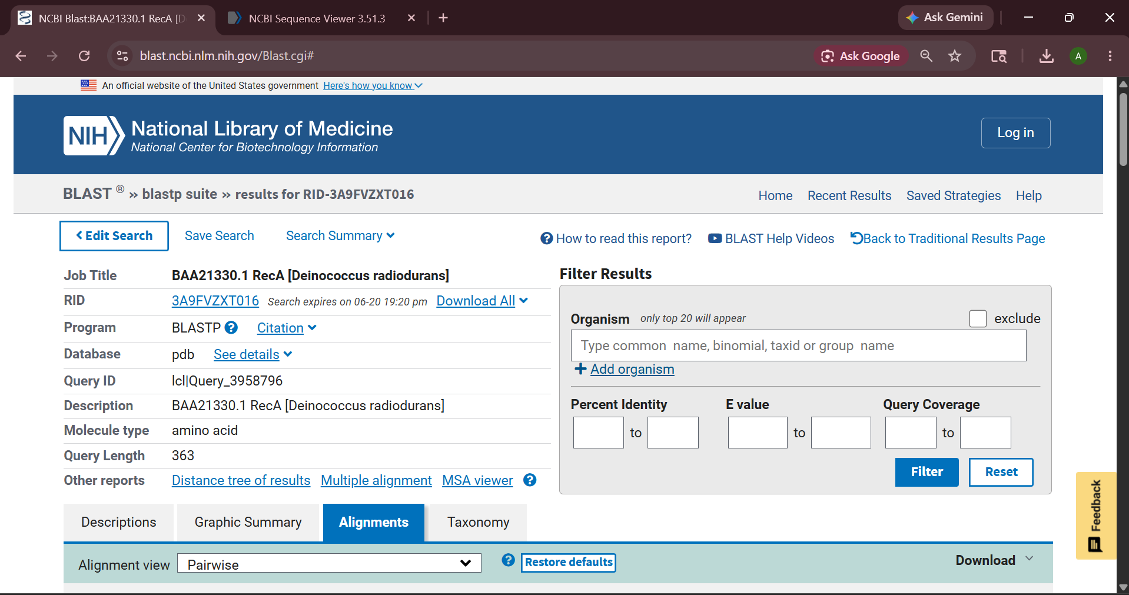
Figure 2. BLASTP job summary showing search parameters and query metadata.

4. Results

4.1 Top-Scoring Alignment
The single best alignment was against PDB entry 1XP8, Chain A — the crystal structure of RecA from Deinococcus radiodurans itself — confirming the correctness of the search and providing a perfect internal control.
- Sequence ID: 1XP8_A (Subject length: 366 aa)
- Bit score: 723 bits (raw score 1865)
- Expect value (E-value): 0.0
- Identity: 363/363 residues (100%)
- Positives (similarity): 363/363 residues (100%)
- Gaps: 0/363 (0%)
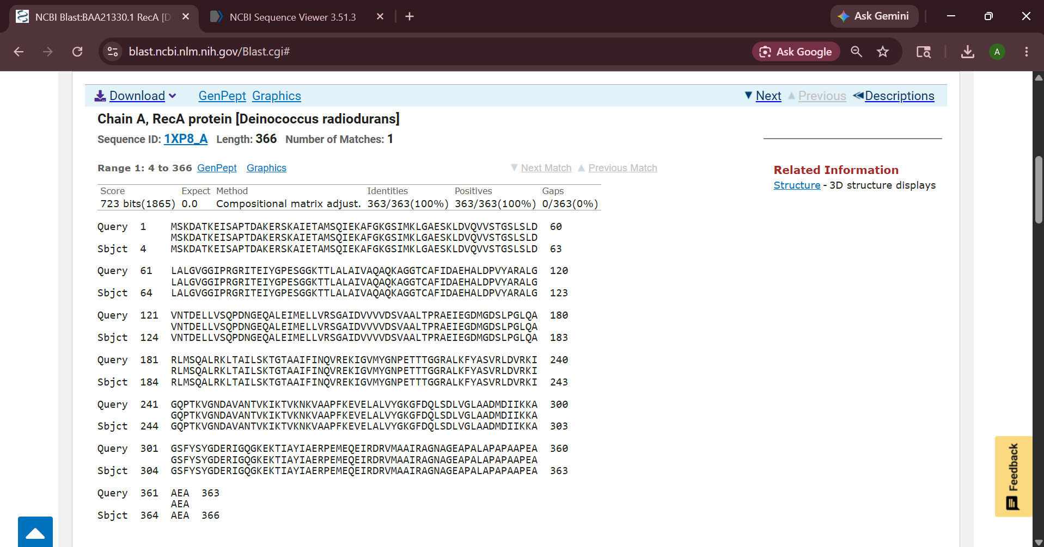
Figure 3. Pairwise alignment of the query sequence against PDB 1XP8 Chain A, showing 100% identity across the full length.

4.2 Homologous Sequences Identified

Beyond the identical match, BLASTP identified 22 additional homologous RecA/RecA-family structures from diverse bacterial (and one archaeal) species, with query coverage generally between 88–96% and percent identity ranging from ~56% to ~65% for true RecA orthologs. The table below summarizes representative top hits, ranked by bit score:

# | Description / Organism | Score | Query Cover | E value | Identity | PDB ID
1 | Chain A, RecA protein — Deinococcus radiodurans | 723 | 100% | 0.0 | 100.00% | 1XP8_A
2 | Chain A, RecA — Mycolicibacterium smegmatis | 415 | 94% | 6e-145 | 59.48% | 1UBC_A
3 | Protein recA — Mycolicibacterium smegmatis MC2 155 | 414 | 94% | 2e-144 | 59.18% | 2ZR0_A
4 | Protein RecA — Streptococcus pneumoniae | 411 | 88% | 9e-143 | 64.71% | 8AMD_A
5 | Protein RecA — Escherichia coli | 409 | 88% | 1e-142 | 61.06% | 7JY6_A
6 | RecA protein — Escherichia coli | 408 | 88% | 3e-142 | 61.06% | 1N03_A
7 | Protein RecA — Klebsiella variicola 342 | 408 | 88% | 3e-142 | 61.06% | 9UOO_A
8 | Protein RecA — Mycobacterium tuberculosis | 406 | 89% | 1e-141 | 58.95% | 4OQF_A
9 | Protein RecA — Herbaspirillum seropedicae | 394 | 96% | 1e-136 | 58.74% | 5JRJ_A
10 | Chain D, Protein RecA — Pseudomonas aeruginosa | 392 | 89% | 5e-136 | 55.96% | 8S70_D
11 | Protein recA — Thermotoga maritima | 368 | 89% | 3e-126 | 55.62% | 3HR8_A
12 | DNA repair/recombination protein RadB — Thermococcus kodakarensis | 57.4 | 44% | 7e-09 | 35.67% | 2CVF_A
Table 1. Selected BLASTP hits against the PDB database (ranked by bit score).
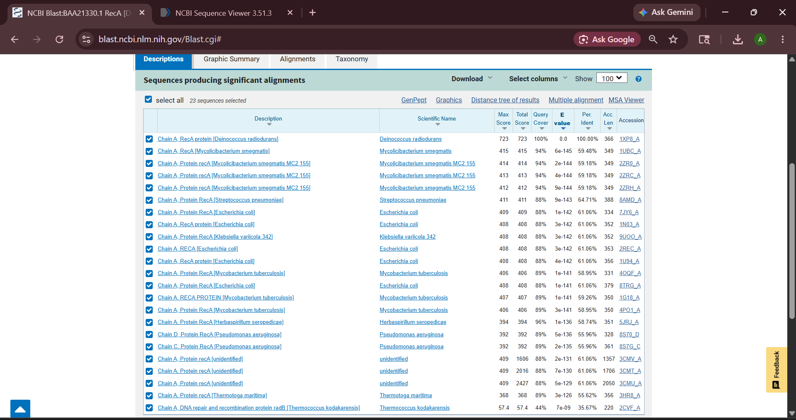
Figure 4. NCBI BLAST "Descriptions" results table (23 significant alignments).

4.3 Conserved Domain / Functional Region Analysis
The Graphic Summary view highlighted conserved functional features embedded within the alignment region, most notably the ATP-binding site and the hexamer interface, both of which are hallmark features of the RecA/RAD51 recombinase superfamily. The conserved-domain search confirmed a specific hit spanning nearly the entire query length (residues ~1–360) that was classified under the RecA superfamily architecture, consistent with the protein's established role in ATP-dependent homologous recombination and DNA strand-exchange.
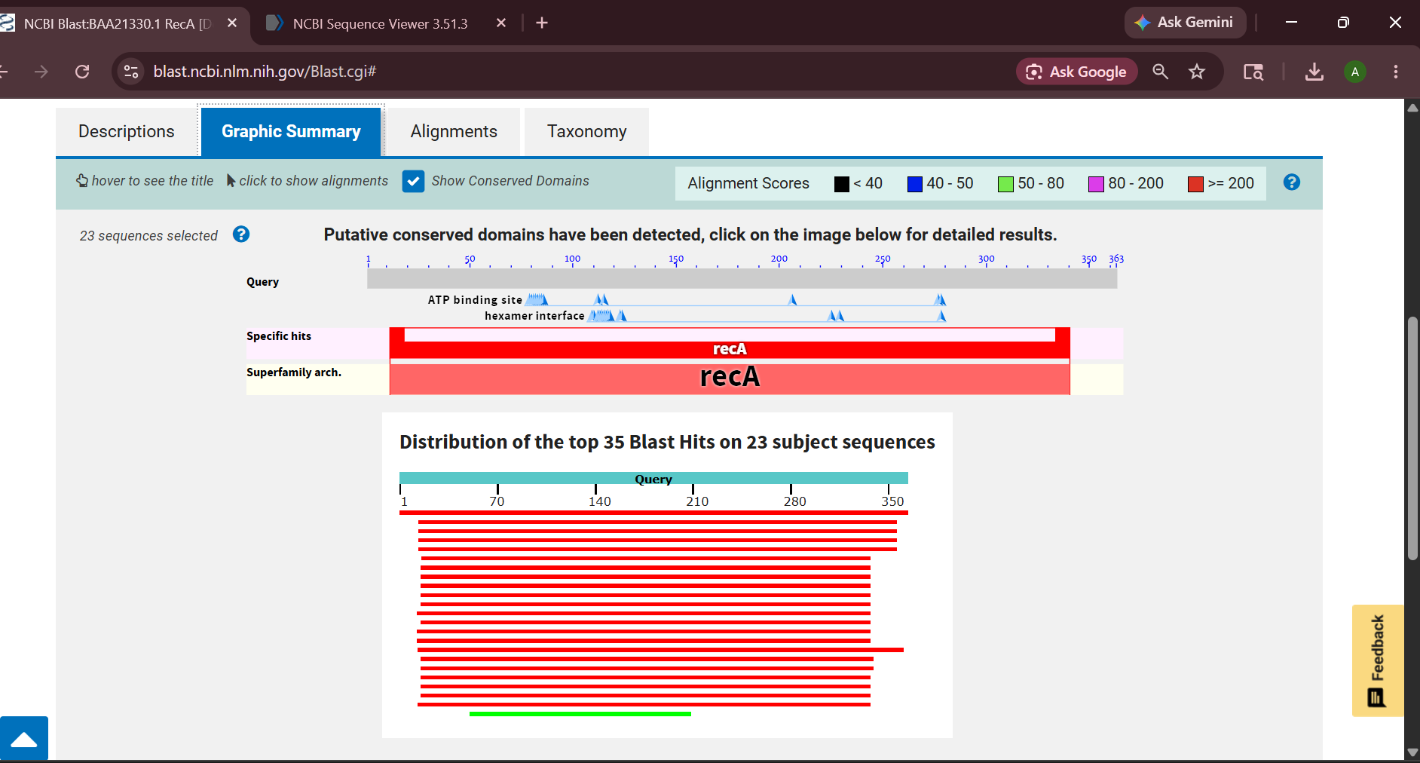
Figure 5. Graphic Summary showing conserved domain architecture (RecA superfamily, ATP-binding site, hexamer interface) and distribution of the top 35 BLAST hits across 23 subject sequences.

5. Discussion
The BLAST results strongly support the identity and evolutionary conservation of RecA as a central DNA-repair protein across bacteria. The top hit (1XP8_A) returning 100% identity with zero gaps validates the search pipeline and confirms that the query sequence was correctly retrieved. More notably, orthologous RecA proteins from taxonomically distant organisms — including Escherichia coli, Mycobacterium tuberculosis, Streptococcus pneumoniae, Pseudomonas aeruginosa, and the hyperthermophile Thermotoga maritima — all returned highly significant E-values (ranging from 0.0 to as low as 7e-09 for the most distant archaeal match) and substantial sequence identity (56–65% for the bacterial orthologs). This pattern reflects strong evolutionary conservation of the RecA fold and its catalytic machinery, particularly the ATP-binding site and hexamer-interface regions that were consistently mapped onto nearly the full length of the query in the conserved-domain analysis.
The most distant hit, DNA repair and recombination protein RadB from the archaeon Thermococcus kodakarensis, showed markedly lower identity (35.67%) and query coverage (44%), yet remained statistically significant (E = 7e-09), illustrating that the core RecA/RadA/RadB recombinase fold has been conserved across the bacterial and archaeal domains of life, even as sequence identity has diverged substantially over evolutionary time.

6. Conclusion
This analysis successfully retrieved the RecA protein sequence of Deinococcus radiodurans from NCBI and used BLASTP against the PDB database to identify homologous, structurally resolved RecA proteins across a wide range of bacterial species and one archaeal representative. The results demonstrate (1) accurate sequence retrieval, confirmed by a perfect self-match; (2) strong conservation of RecA across bacteria, with 55–65% identity and highly significant E-values; and (3) conservation of key functional domains — the ATP-binding site and hexamer interface — that underlie RecA's essential role in homologous recombination and DNA damage repair, a function of particular importance in the extreme radiation resistance of D. radiodurans.

